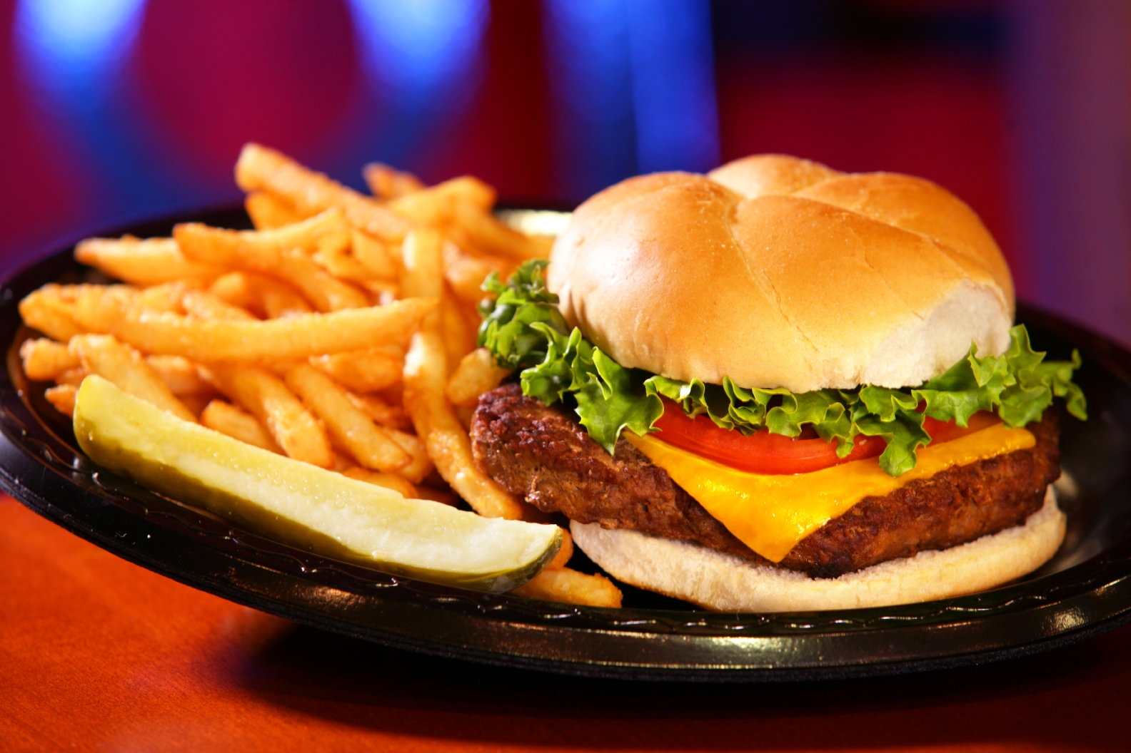

Location

Gift Cards

Careers

Social Media

Address

Phone

Email

Hours

Sun – Sat: 9 – 2am

Happy Hour: 4 – 6pm

Apps

Desserts

Drinks

Burgers

101

ReservationDate:_____

Time:_____

Submit

Menu | About US | Location | Contact Us | Reservation

Ones And Zeros